**HOUSE RENT APPLICATION USING MERN**

**TEAM MEMBERS:**

* M.Venkatesh

(NM_id:B4AA16EE5D067FFAEDC455B77A72288A)

* B.Vignesh

(NM_id: 0B4F0203E88AD5ABBDC4E02846ECB8B7)

* S.Vignesh Kumar

(NM_id: A4B5931F286BABABE234D50FB1A2BD38)

* M.Vimal Babu

(NM_id: 234F836F50C937C968E48E3963D7207E)

# TABLE OF CONTENT

1. ABSTRACT

1. MERN STACK

* + MONGODB

* + EXPRESS
  + REACT
  + NODE JS

1. MONGODB

1. PROJECT DESCRIPTION

1. TECHNICAL ARCHITECTURE

1. FRONT END

1. BACK END

1. DATABASE

1. INTEGRATION

1. OUTPUT
2. CONCLUSION
3. RESULT

**CREATE A WEBSITE FOR HOUSE RENTAL**

**APPLICATION SYSTEM USING MERN STACK**

**ABSTRACT:**

This research paper explores the development of a comprehensive house rental platform, "Rent Easy," utilizing the MERN stack, a robust combination of technologies including MongoDB, Express.js, React.js, and Node.js. The platform aims to connect landlords and tenants, streamlining the process of finding and renting properties.

The frontend, developed using React.js, offers an intuitive user interface with features such as:

* **Property Listings:** Detailed property listings with images, descriptions, location, rent, and amenities.
* **Advanced Search:** A powerful search engine to filter properties based on location, price, property type, and other criteria.
* **User Profiles:** Customizable profiles for landlords and tenants to showcase their information and preferences.
* **Messaging System:** A secure messaging system for direct communication between landlords and tenants.
* **Booking and Payment System:** A streamlined booking and payment process, integrated with secure payment gateways.

The backend, powered by Node.js and Express.js, handles server-side logic and API endpoints. Key functionalities include:

* **Property Management:** Managing property listings, including adding, editing, and removing properties.
* **User Authentication and Authorization:** Secure user authentication and authorization to protect user accounts and data.
* **Booking and Payment Processing:** Processing booking requests and handling payments securely.

**MERN STACK:**

The MERN stack is a popular collection of JavaScript-based technologies used to build dynamic web applications. It stands for MongoDB, Express.js, React, and Node.js. Each component plays a crucial role in the development process, offering a cohesive and efficient solution for creating robust web applications.

**Key Components of the MERN Stack:**

1. **MongoDB:**
   * A flexible, NoSQL database that stores data in JSON-like documents.
   * o Offers high scalability and performance, making it suitable for handling large amounts of data.
   * o Easy to learn and use, especially for developers familiar with JavaScript.
2. **Express.js:**
   * A minimalist web framework for Node.js that simplifies server-side development.

o Provides a robust set of features for handling HTTP requests, routing, and middleware.

* + o Allows developers to build RESTful APIs and handle server-side logic efficiently.

1. **React:**
   * A powerful JavaScript library for building user interfaces.
   * o Enables the creation of reusable UI components, leading to faster development and easier maintenance.
   * o Offers a virtual DOM for efficient updates and a component-based architecture.
2. **Node.js:**
   * A JavaScript runtime environment that allows you to execute JavaScript code outside of a browser.
   * Provides a non-blocking, event-driven architecture for efficient handling of multiple requests.

o Enables the creation of server-side applications, APIs, and Realtime applications.

**Why Choose MERN Stack?**

* **JavaScript Unification:** Uses JavaScript throughout the entire stack, reducing the learning curve and promoting code consistency.
* **Rapid Development:** The component-based approach of React and the simplicity of Express.js accelerate development.
* **Scalability:** MongoDB's flexible data model and Node.js's non-blocking architecture allow for scaling applications to handle increasing loads.
* **Rich Ecosystem:** A large and active community provides extensive support, libraries, and frameworks.
* **Full-Stack Development:** Covers both frontend and backend development, enabling developers to build complete applications.

**Common Use Cases:**

* **Web Applications:** Building dynamic web applications with interactive user interfaces.
* **Real-time Applications:** Creating real-time chat applications, collaborative tools, and online gaming platforms.
* **Mobile Applications:** Developing cross-platform mobile apps using frameworks like React Native.
* **Server-Side Rendering (SSR):** Improving SEO and initial page load performance.

By understanding the core components and benefits of the MERN stack, developers can leverage its power to create innovative and high-performance web applications.

**MONGODB:**

MongoDB is a popular, open-source, document-oriented NoSQL database. Unlike traditional relational databases that store data in tables, MongoDB stores data in flexible, JSON-like documents. This makes it highly adaptable to various data structures, making it a versatile choice for a wide range of applications.

**Key Features of MongoDB:**

* **Document Model:**
  + Data is stored in flexible, JSON-like documents.

o Each document can have a different structure, making it easy to adapt to changing data requirements.

* **Schema-less Design:**
  + MongoDB does not enforce a strict schema, allowing for dynamic data modelling.

o This flexibility makes it easier to evolve your data structures over time.

* **High Performance:**
  + MongoDB is designed for high performance and scalability.

o It uses advanced indexing techniques and efficient query optimization to deliver fast query results.

* **Rich Query Language:**
  + MongoDB's query language, based on JSON, is powerful and expressive.

o It supports complex queries, aggregations, and full-text search.

* **Horizontal Scalability:**
  + MongoDB can be easily scaled horizontally by adding more servers to a cluster.

o This allows you to handle increasing data volumes and traffic.

* **High Availability:**
  + MongoDB offers robust replication and sharding mechanisms to ensure high availability and data durability.

**Common Use Cases:**

* **Web Applications:** Building dynamic web applications with complex data structures.
* **Mobile Applications:** Storing user data, preferences, and application state.
* **IoT Applications:** Handling large volumes of time-series data from IoT devices.
* **Real-time Analytics:** Processing and analysing data in real-time.
* **Content Management Systems:** Storing and managing large amounts of content.

**PROJECT DESCRIPTION:**

A house rent app is typically a mobile or web application designed to help users find rental properties, apartments, or houses for rent. These apps often offer features to make the process of searching for and renting a property more convenient and efficient. Here are some common features you might find in a house rent app:

**Property Listings**: The app provides a database of available rental properties, complete with detailed descriptions, photos, location, rent amount, and other relevant information.

**Search Filters**: Users can apply various filters to narrow down their search results based on criteria such as location, rent range, property type (apartment, house, room, etc.), number of bedrooms, amenities, and more.

**Contact Landlords/Property Managers**: The app might provide a way for users to contact the property owners or managers directly through the app, often through messaging or email.

**SOURCE CODE:**

**Index.html**:

<!DOCTYPE html>

<html lang="en">

<head>

<meta charset="utf-8">

<meta name="viewport" content="width=device-width, initial-scale=1, shrink-to-fit=no">

<meta name="theme-color" content="#000000">

<!--

manifest.json provides metadata used when your web app is added to the

homescreen on Android. See https://developers.google.com/web/fundamentals/engage-and-retain/web-app-manifest/

-->

<link rel="manifest" href="%PUBLIC_URL%/manifest.json">

<link rel="shortcut icon" href="%PUBLIC_URL%/favicon.ico">

<link rel="stylesheet" href="https://maxcdn.bootstrapcdn.com/bootstrap/3.3.7/css/bootstrap.min.css">

<!-- <link rel="stylesheet" href="https://maxcdn.bootstrapcdn.com/bootstrap/4.0.0/css/bootstrap.min.css" integrity="sha384-Gn5384xqQ1aoWXA+058RXPxPg6fy4IWvTNh0E263XmFcJlSAwiGgFAW/dAiS6JXm"

crossorigin="anonymous"> -->

<script src="https://ajax.googleapis.com/ajax/libs/jquery/3.3.1/jquery.min.js"></script>

<script src="https://maxcdn.bootstrapcdn.com/bootstrap/3.3.7/js/bootstrap.min.js"></script>

<script src="https://code.jquery.com/jquery-3.2.1.slim.min.js" integrity="sha384-KJ3o2DKtIkvYIK3UENzmM7KCkRr/rE9/Qpg6aAZGJwFDMVNA/GpGFF93hXpG5KkN"

crossorigin="anonymous"></script>

<script src="https://cdnjs.cloudflare.com/ajax/libs/popper.js/1.12.9/umd/popper.min.js" integrity="sha384-ApNbgh9B+Y1QKtv3Rn7W3mgPxhU9K/ScQsAP7hUibX39j7fakFPskvXusvfa0b4Q"

crossorigin="anonymous"></script>

<script src="https://maxcdn.bootstrapcdn.com/bootstrap/4.0.0/js/bootstrap.min.js" integrity="sha384-JZR6Spejh4U02d8jOt6vLEHfe/JQGiRRSQQxSfFWpi1MquVdAyjUar5+76PVCmYl"

crossorigin="anonymous"></script>

<!--

Notice the use of %PUBLIC_URL% in the tags above.

It will be replaced with the URL of the `public` folder during the build.

Only files inside the `public` folder can be referenced from the HTML.

Unlike "/favicon.ico" or "favicon.ico", "%PUBLIC_URL%/favicon.ico" will

work correctly both with client-side routing and a non-root public URL.

Learn how to configure a non-root public URL by running `npm run build`.

-->

<title>React App</title>

</head>

<body>

<noscript>

You need to enable JavaScript to run this app.

</noscript>

<div id="root"></div>

<!--

This HTML file is a template.

If you open it directly in the browser, you will see an empty page.

You can add webfonts, meta tags, or analytics to this file.

The build step will place the bundled scripts into the <body> tag.

To begin the development, run `npm start` or `yarn start`.

To create a production bundle, use `npm run build` or `yarn build`.

-->

</body>

</html>

**App.js:**

import React, { Component } from "react";

//import logo from "./logo.svg";

import "./App.css";

import { BrowserRouter } from "react-router-dom";

import Main from "./Main";

import { ApolloProvider } from "react-apollo";

import ApolloClient from "apollo-boost";

const client = new ApolloClient({

uri: "http://localhost:8080/graphql"

});

class App extends Component {

render() {

return (

<BrowserRouter>

<ApolloProvider client={client}>

<div>

{/* App Component Has a Child Component called Main*/}

<Main />

</div>

</ApolloProvider>

</BrowserRouter>

);

}

}

export default App;

**index.js:**

import React from "react";

import ReactDOM from "react-dom";

import { createStore, applyMiddleware, combineReducers } from "redux";

import { Provider } from "react-redux";

import "./index.css";

import App from "./App";

import reducer from "./store/reducer";

import loginreducer from "./store/Reducers/loginreducer";

import postpropertyreducer from "./store/Reducers/postpropertyreducer";

import bookpropertyreducer from "./store/Reducers/bookpropertyreducer";

import profilereducer from "./store/Reducers/profilereducer";

import signupreducer from "./store/Reducers/signupreducer";

import promise from "redux-promise";

import thunk from "redux-thunk";

import { createLogger } from "redux-logger";

import registerServiceWorker from "./registerServiceWorker";

import { composeWithDevTools } from "redux-devtools-extension";

import ApolloClient from "apollo-boost";

import { ApolloProvider } from "react-apollo";

const rootReducer = combineReducers({

login: loginreducer,

postproperty: postpropertyreducer,

bookproperty: bookpropertyreducer,

profile: profilereducer,

signup: signupreducer

});

// apollo client setup

// const client = new ApolloClient({

// uri: "http://localhost:8080/graphql"

// });

const loggerMiddleware = createLogger();

//const store = createStore(reducer, composeWithDevTools(applyMiddleware(thunk)));

const store = createStore(

rootReducer,

composeWithDevTools(applyMiddleware(thunk, loggerMiddleware))

);

ReactDOM.render(

<Provider store={store}>

<App />

</Provider>,

document.getElementById("root")

);

registerServiceWorker();

**Main.js:**

import React, { Component } from "react";

import { Route } from "react-router-dom";

import Login from "./Login";

import Home from "./Home";

import Navbar from "./Navbar";

import Profile from "./Profie";

import Signup from "./Signup";

import ListProperty from "./ListProperty";

import Location from "./Location";

import Publish from "./Publish";

import moment from "moment";

import PropertyList from "./components/PropertyList";

import OwnerLogin from "./components/OwnerLogin";

import TripBoards from "./components/Tripboards";

import OwnerDashboard from "./components/OwnerDashboard";

import HomePage from "./components/HomePage";

import OwnerSignup from "./components/OwnerSignup";

import Inbox from "./components/MessageBox";

import { connect } from "react-redux";

class Main extends Component {

  constructor() {

    super();

    this.state = {

      propDetails: {

        Bed: 0,

        Bath: 0

      },

      userId: "",

      isAuthenticated: false,

      searchDetails: {},

      fromDate: moment(),

      toDate: moment(),

      location: "",

      isSearch: "",

      adults: "",

      kids: "",

      isSearch: false

    };

    this.handleSearchChange = this.handleSearchChange.bind(this);

    this.handleSearchSubmit = this.handleSearchSubmit.bind(this);

  }

  userHasAuthenticated = authenticated => {

    this.setState({ isAuthenticated: authenticated });

    console.log("isAuthenticated", this.state.isAuthenticated);

  };

  changeRoom(bed, bath) {

    const newState = this.state.propDetails;

    newState.Bath = bath;

    newState.Bed = bed;

    this.setState({ propDetails: newState });

  }

  getUserId = id => {

    console.log("and the id is", id);

    //  this.setState({ userId: id });

    //   localStorage.setItem("userId", id);

  };

  componentDidMount() {

    // var result = localStorage.getItem("userId");

    // this.setState({ userId: result });

    // console.log("result is", result);

  }

  handleSearchChange(event) {

    this.setState({ [event.target.name]: event.target.value });

  }

  handleSearchSubmit(event) {

    console.log(JSON.stringify(this.state));

    this.setState({

      isSearch: true

    });

  }

  handleDateChange = (name, date) => {

    console.log("name and date", name, date.target.value);

    //const date1 = date.toDate();

    if (name === "fromDate") {

      this.setState({

        fromDate: date.target.value

      });

    }

    console.log("name date", date.target.value);

    if (name === "toDate") {

      this.setState({

        toDate: date.target.value

      });

    }

    //this.toggleCalendar();

  };

  render() {

    const childProps = {

      isAuthenticated: this.state.isAuthenticated,

      userHasAuthenticated: this.userHasAuthenticated

    };

    return (

      <div>

        <Route exact path="/" component={HomePage} />

        {/* <Route path="/login" component={Login} /> */}

        {/* <Route path="/home" component={Home} /> */}

        <Route

          exact

          path="/home"

          render={() => {

            return (

              <Home

                fromDate={this.state.fromDate}

                toDate={this.state.toDate}

                change={this.handleSearchChange}

                handleDateChange={this.handleDateChange}

                location={this.state.location}

                adults={this.state.adults}

                kids={this.state.kids}

                handleSearchSubmit={this.handleSearchSubmit}

                isSearch={this.state.isSearch}

              />

            );

          }}

        />

        <Route

          exact

          path="/property-list"

          render={() => {

            return (

              <PropertyList

                fromDate={this.state.fromDate}

                toDate={this.state.toDate}

                //   change={this.handleSearchChange}

                //  handleDateChange={this.handleDateChange}

                location={this.state.location}

                adults={this.state.adults}

                kids={this.state.kids}

                //  handleSearchSubmit={this.handleSearchSubmit}

                // isSearch={this.state.isSearch}

              />

            );

          }}

        />

        <Route exact path="/signup" component={Signup} />

        <Route exact path="/ownerSignup" component={OwnerSignup} />

        {/* <Route path="/profile" component={Profile} /> */}

        <Route

          path="/profile"

          render={() => {

            return <Profile userId={this.state.userId} />;

          }}

        />

        <Route

          exact

          path="/ListProperty"

          render={() => {

            return <ListProperty changeRoom={this.changeRoom.bind(this)} />;

          }}

        />

        <Route

          exact

          path="/Location"

          render={() => {

            return (

              <Location

                userid={this.state.userId}

                room={this.state.propDetails}

              />

            );

          }}

        />

        <Route

          exact

          path="/login"

          render={() => {

            return <Login loadUser={this.getUserId} />;

          }}

        />

        <Route

          exact

          path="/ownerLogin"

          render={() => {

            return <OwnerLogin loadUser={this.getUserId} />;

          }}

        />

        <Route exact path="/Publish" component={Publish} />

        <Route exact path="/tripboards" component={TripBoards} />

        <Route exact path="/OwnerDashboard" component={OwnerDashboard} />

        <Route exact path="/Inbox" component={Inbox} />

      </div>

    );

  }

}

export default Main;

**SCENARIO BASED CASE STUDY**:

User Registration: Alice, who is looking for a new apartment, downloads your house rent app and registers as a Renter. She provides her email and creates a password.

Browsing Properties: Upon logging in, Alice is greeted with a dashboard showcasing available rental properties. She can see listings with detailed descriptions, photos, and rental information.

She applies filters to narrow down her search, specifying her desired location, rent range, and the number of bedrooms.

Property Inquiry: Alice finds an apartment she likes and clicks on it to get more information. She sees the property details and owner's contact information.

Interested in renting, Alice fills out a small form with her details and sends it to the owner.

Booking Confirmation: The owner receives Alice's inquiry and reviews her details. Satisfied, the owner approves Alice's booking request.

Alice receives a notification that her booking is confirmed, and the status in her dashboard changes to "pending owner confirmation."

Admin Approval (Background Process): In the background, the admin reviews new owner registrations and approves legitimate users who want to add properties to the app.

Owner Management: Bob, a property owner, signs up for an Owner account on the app and submits a request for approval.

The admin verifies Bob's credentials and approves his Owner account.

Property Management: With his Owner account approved, Bob can now add, edit, or delete properties in his account.

He updates the status and availability of his properties based on their occupancy.

Platform Governance: Meanwhile, the admin ensures that all users adhere to the platform's policies, terms of service, and privacy regulations.

The admin monitors activities to maintain a safe and trustworthy environment for all users.

Transaction and Lease Agreement: Once Alice's booking is confirmed, she and the owner negotiate the terms of the lease agreement through the app's messaging system.

They finalize the rental contract and payment details within the app, ensuring transparency and security.

Move-in Process: Alice successfully moves into her new apartment, marking the completion of the rental process facilitated by the house rent app.

**TECHNICAL ARCHITECTURE:**

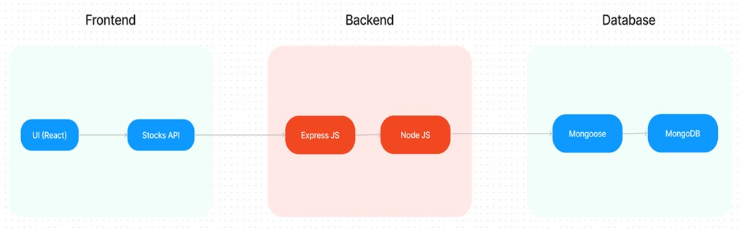

The technical architecture of our House rent app follows a client-server model, where the frontend serves as the client and the backend acts as the server. The frontend encompasses not only the user interface and presentation but also incorporates the axios library to connect with backend easily by using RESTful Apis.

The frontend utilizes the bootstrap and material UI library to establish real-time and better UI experience for any user whether it is admin, doctor and ordinary user working on it.

On the backend side, we employ Express.js frameworks to handle the serverside logic and communication.

For data storage and retrieval, our backend relies on MongoDB. MongoDB allows for efficient and scalable storage of user data, including user profiles, for booking room, and adding room, etc. It ensures reliable and quick access to the necessary information.

Together, the frontend and backend components, along with moment,

Express.js, and MongoDB, form a comprehensive technical architecture for our House rent app. This architecture enables real-time communication, efficient data exchange, and seamless integration, ensuring a smooth and immersive booking an appointment and many more experience for all users.

**FRONTEND:**

The frontend of a house rental platform, built using React.js, serves as the primary interface for landlords and tenants to interact with the platform. It's crucial to design a user-friendly and intuitive interface that guides users through the rental process seamlessly.

**Key Components and Features:**

1. **Homepage:**

o **Hero Section:** A visually appealing header showcasing the platform's value proposition and a search bar for quick property searches.

o **Featured Listings:** A curated selection of popular or trending properties, often presented in a carousel or grid format.

o **How It Works:** A simple explanation of the platform's workflow, emphasizing ease of use.

o **Testimonials:** Positive reviews from satisfied landlords and tenants.

1. **Property Listings:**
   * **Advanced Search:** A powerful search engine to filter properties based on location, price, property type, amenities, and other criteria.
   * **Detailed Property Listings:** Detailed property descriptions, including images, location, rent, amenities, and contact information.

o **Virtual Tours:** Integration with virtual tour technology to provide immersive property experiences.

o **Property Maps:** Interactive maps to visualize property locations and nearby amenities.

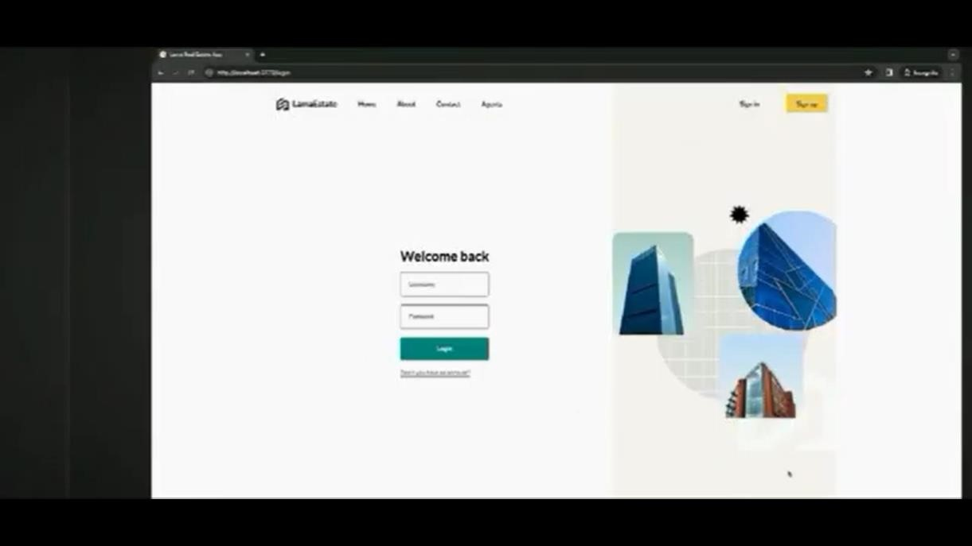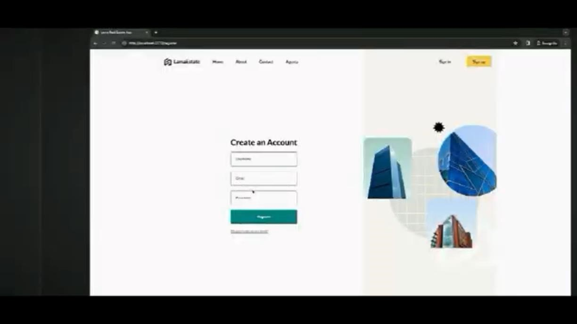

1. **User Profiles:**
   * + **Profile Information:** A section to edit personal information, contact details, and preferences.
     + **Property Listings (for landlords):** A dashboard to manage property listings, including adding, editing, and removing properties.

o **Booking History (for tenants):** A history of past bookings and rentals.

o **Messages:** A messaging system to communicate with other users.

1. **Booking and Payment:**

o **Booking Request:** A simple booking request form for tenants to express interest in a property.

o **Secure Payment Gateway Integration:** Integration with secure payment gateways like Stripe or PayPal to process rental payments.

o **Rental Agreements:** Digital rental agreements that can be signed electronically.

o **Tenant Screening:** A system to screen tenants' credit history and rental history.

1. **Messaging System:**

o **Direct Messaging:** A private messaging system for direct communication between landlords and tenants.

o **Group Chats:** Group chat functionality for discussions between multiple parties.

o **File Sharing:** Ability to share documents and images within the messaging system.

**User Experience (UX) Best Practices:**

* **Intuitive Navigation:** A clear and intuitive navigation structure to guide users through the platform.
* **Responsive Design:** Ensuring the platform adapts to different screen sizes for optimal viewing on desktops, tablets, and mobile devices.
* **Fast Loading Times:** Optimizing images, minimizing HTTP requests, and leveraging browser caching to improve performance.
* **Error Handling:** Implementing robust error handling mechanisms to provide informative error messages and guide users to resolve issues.
* **Accessibility:** Adhering to web accessibility standards (WCAG) to make the platform usable by people with disabilities.

**BACKEND:**

The backend of a house rental platform, powered by Node.js and Express.js, serves as the invisible backbone that supports the frontend's functionality. It handles data storage, user authentication, property management, and other critical operations.

**Core Functionalities:**

1. **User Authentication and Authorization:**
   * **User Registration and Login:** Implement robust user registration and login functionalities.

o **Password Hashing:** Use strong password hashing algorithms like crypts to protect user passwords.

o **Session Management:** Implement session management techniques to maintain user sessions and track user activity.

* + **Role-Based Access Control:** Implement role-based access control to restrict access to specific functionalities based on user roles (e.g., landlord, tenant, admin).

1. **Property Management:**
   * **Property Listings:** Allow landlords to create, edit, and delete property listings.

o **Property Search and Filtering:** Implement a robust search and filtering system to help tenants find suitable properties.

o **Property Verification:** Implement a verification process to validate property listings.

1. **Booking and Payment:**
   * **Booking Requests:** Handle booking requests from tenants and send notifications to landlords.

o **Payment Processing:** Integrate with payment gateways to process rental payments securely.

o **Rental Agreements:** Generate digital rental agreements and store them securely.

1. **Messaging System:**
   * **Direct Messaging:** Implement a direct messaging system for communication between landlords and tenants.

o **Notification System:** Send notifications for booking confirmations, payment reminders, and property updates.

1. **Data Storage and Retrieval:**
   * **Database Interaction:** Use MongoDB to store property listings, user profiles, booking information, and messages.

o **Data Validation and Sanitization:** Validate and sanitize user input to prevent security vulnerabilities.

**Technical Considerations:**

* **Scalability:** Design the backend to handle increasing traffic and data volume.
* **Performance Optimization:** Implement caching mechanisms, asynchronous programming, and database optimization techniques.
* **Security:** Protect user data and prevent security vulnerabilities through measures like input validation, output encoding, and secure communication protocols.
* **Error Handling and Logging:** Implement robust error handling mechanisms to gracefully handle exceptions and log errors for debugging and analysis.
* **Testing:** Thoroughly test the backend using unit tests, integration tests, and end-to-end tests.

**DATABASE:**

A well-structured database is the foundation of a reliable and efficient house rental platform. It stores crucial information about properties, users, bookings, and messages.

Core Entities:

1. Property:

o PropertyID (Primary Key) o Address

* + PropertyType (House, Apartment, etc.)

o Rent

o Amenities

o Description

* + LandlordID (Foreign Key to User)

1. User:

o UserID (Primary Key)

o Name

* + Email

o PasswordHash

o PhoneNumber

* + Role (Landlord, Tenant)

1. Booking:
   * BookingID (Primary Key)

o PropertyID (Foreign Key to Property)

o TenantID (Foreign Key to User)

o StartDate

* + EndDate

o RentAmount

1. Message:
   * MessageID (Primary Key)

o SenderID (Foreign Key to User)

o ReceiverID (Foreign Key to User)

o MessageText

* + Timestamp Database Design Considerations:

1. Normalization:
   * Break down large entities into smaller, more focused tables to reduce redundancy and improve data integrity.

o Use foreign keys to establish relationships between tables.

1. Indexing:
   * Create indexes on frequently queried columns to improve query performance.

o Consider indexing columns used in WHERE, JOIN, and ORDER BY clauses.

3. Data Types:

* + Choose appropriate data types for each column, such as VARCHAR for text, INT for numbers, DATE for dates, and TIMESTAMP for timestamps.

o Use ENUM or SET for predefined values.

4. Security:

* + Implement strong security measures to protect sensitive user data.
  + Encrypt passwords and other sensitive information.

o Use firewalls and intrusion detection systems to prevent unauthorized access.

1. Scalability:
   * Design the database to handle increasing amounts of data and users.

Consider using sharding or partitioning to distribute the load across multiple servers.

Employ caching mechanisms to reduce database load.

1. Backup and Recovery:
   * Regularly back up the database to protect against data loss.

o Implement a disaster recovery plan to restore the database in case of failures.

**INTEGRATION:**

In a MERN stack application, the integration between the frontend, backend, and database is seamless and efficient. Here's a breakdown of how they interact:

1. Frontend (React):
   * User Interface: Creates the visual components that users interact with, such as property listings, user profiles, messaging, and booking forms.
   * User Interaction: Handles user input, such as property searches, message sending, and booking requests.
   * API Requests: Sends HTTP requests to the backend API to fetch or send data, including:

o Property listings

o User authentication and authorization

o Booking and payment information

o Messages

1. Backend (Node.js and Express.js):
   * API Endpoints: Defines and implements API endpoints to handle requests from the frontend:

o Property-related endpoints (create, read, update, delete) o User authentication and authorization endpoints

o Booking and payment endpoints

o Messaging endpoints

* + Database Interactions: Uses MongoDB to:

Store and retrieve property listings, user profiles, bookings, and messages.

Process user actions, such as creating property listings, making bookings, and sending messages.

* + Response Generation: Processes requests, interacts with the database, and generates appropriate responses in JSON format.

1. Database (MongoDB):
   * Data Storage: Stores all the application data, including:
     + Property listings (address, rent, amenities, landlord information)

o User profiles (name, email, password, phone number)

o Bookings (property, tenant, dates, rent)

o Messages

* + Data Retrieval: Provides data to the backend API when requested.
  + Data Updates: Updates data based on user actions, such as creating a property listing, making a booking, or sending a message.

Integration Mechanisms:

* + RESTful APIs: The frontend and backend communicate using RESTful APIs. The frontend sends HTTP requests (GET, POST, PUT, DELETE) to the backend API endpoints, and the backend processes these requests and sends appropriate responses.
  + JSON Format: Data is exchanged between the frontend and backend in JSON format, which is easy to parse and understand by both.
  + Database Queries: The backend uses MongoDB's query language to retrieve, insert, update, and delete data from the database.
  + Asynchronous JavaScript and XML (AJAX): The frontend uses AJAX to make asynchronous requests to the backend, allowing for dynamic updates without full page reloads.

Example Workflow:

1. User Searches for a Property:
   * + Frontend sends a search query to the backend API with the desired criteria.

Backend queries the database and returns a list of matching properties.

Frontend displays the search results.

1. User Books a property:
   * + Frontend sends the booking details (property ID, tenant ID, dates) to the backend API.

o Backend creates a booking record in the database and sends a confirmation email to both the landlord and tenant.

1. Landlord and Tenant Communicate:
   * + Users send and receive messages through the frontend.

o Frontend sends message data to the backend API.

o Backend stores the messages in the database and sends notifications to the recipients.

**OUTPUT:**

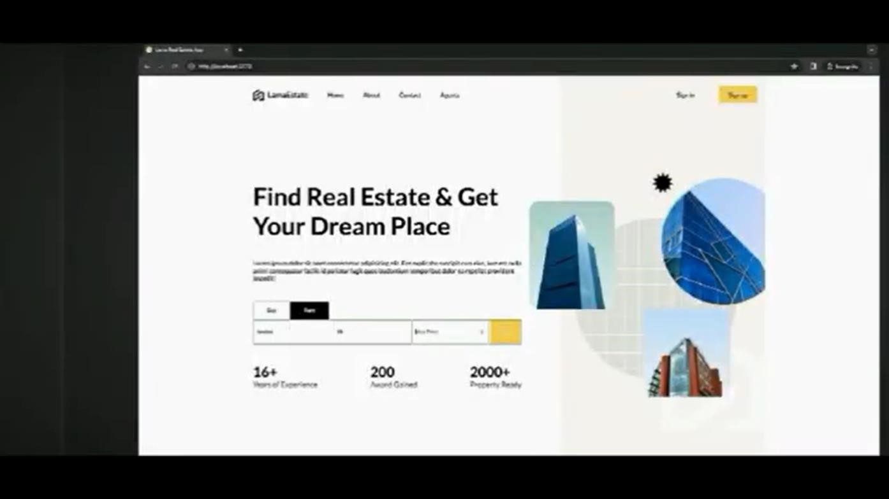

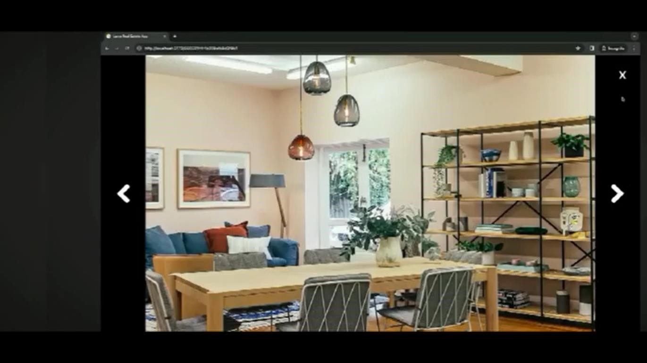

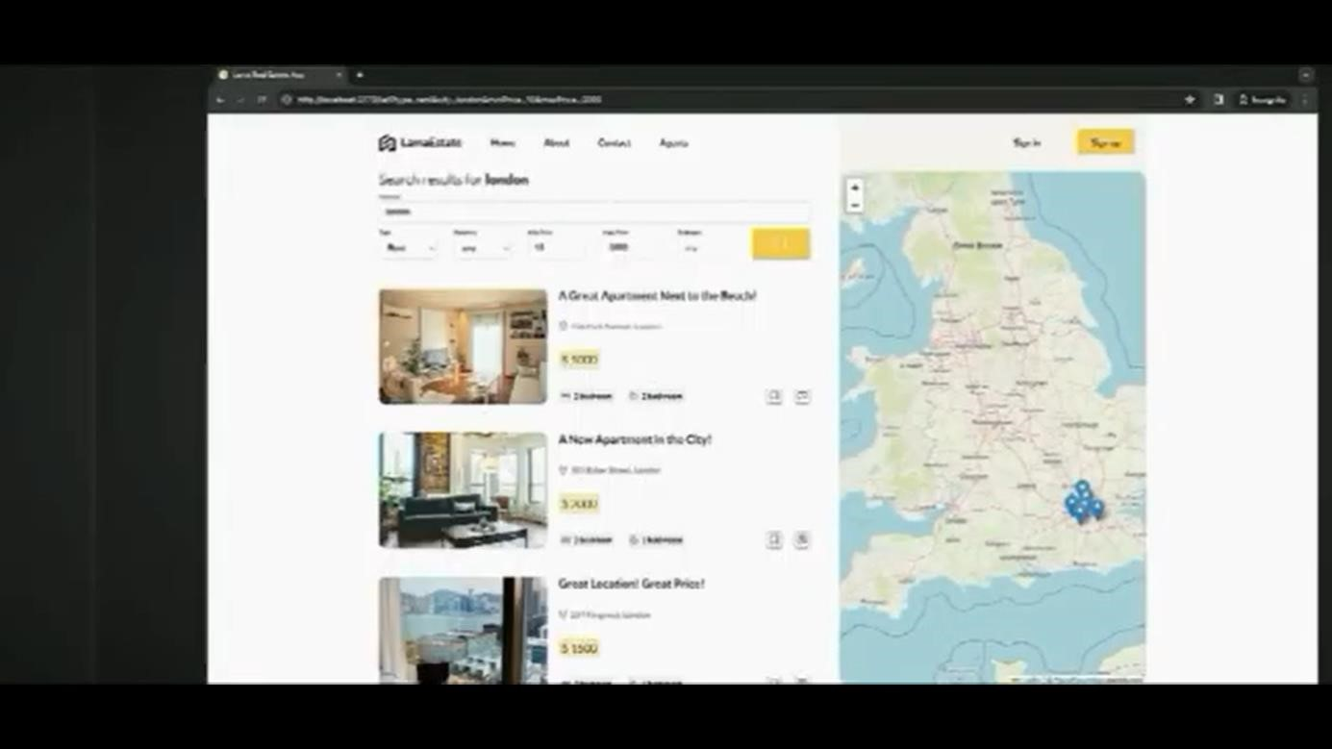

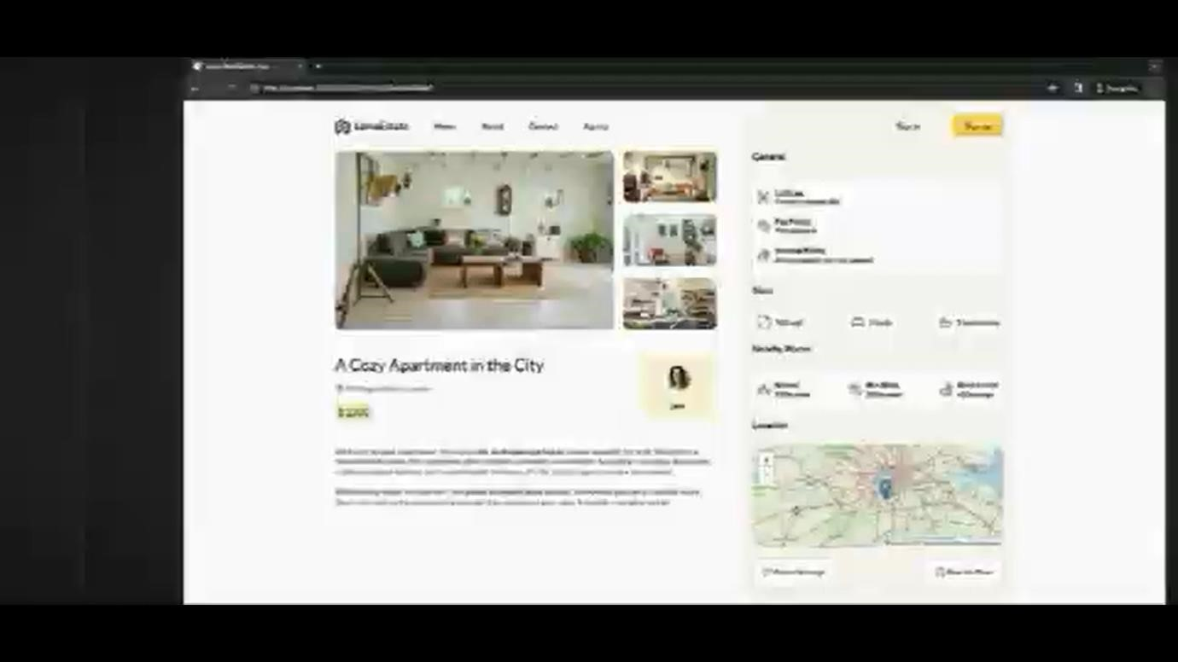

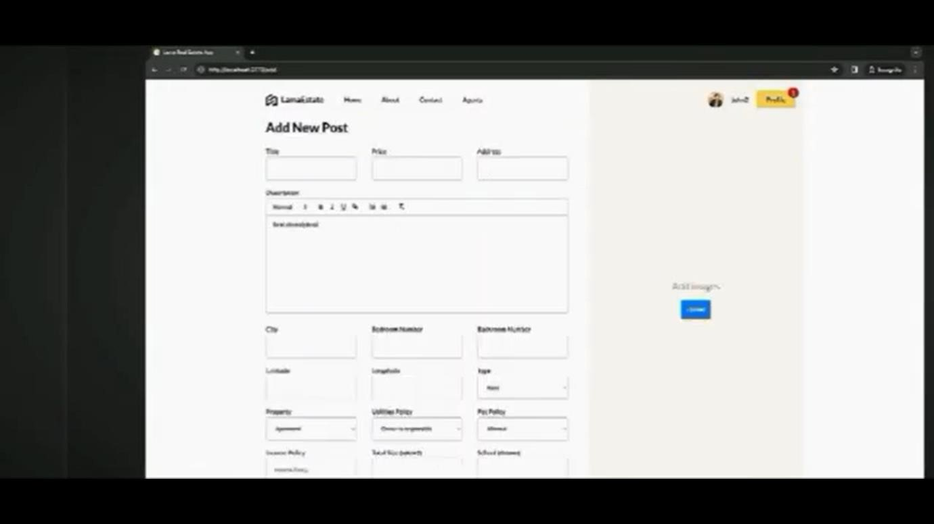

**CONCLUSION:**

The MERN stack, comprising MongoDB, Express.js, React.js, and Node.js, provides a powerful and flexible framework for building robust and scalable house rental platforms. By effectively integrating frontend, backend, and database components, we can create user-friendly, efficient, and secure platforms that empower landlords and tenants to connect and find suitable accommodations.

RESULT:

The MERN stack offers a robust solution for building house rental platforms. By effectively integrating frontend, backend, and database components, developers can create user-friendly, efficient, and secure platforms that empower landlords and tenants to connect and find suitable accommodations.